Spirituality Commission July 2023
Kathy Herfel, chair
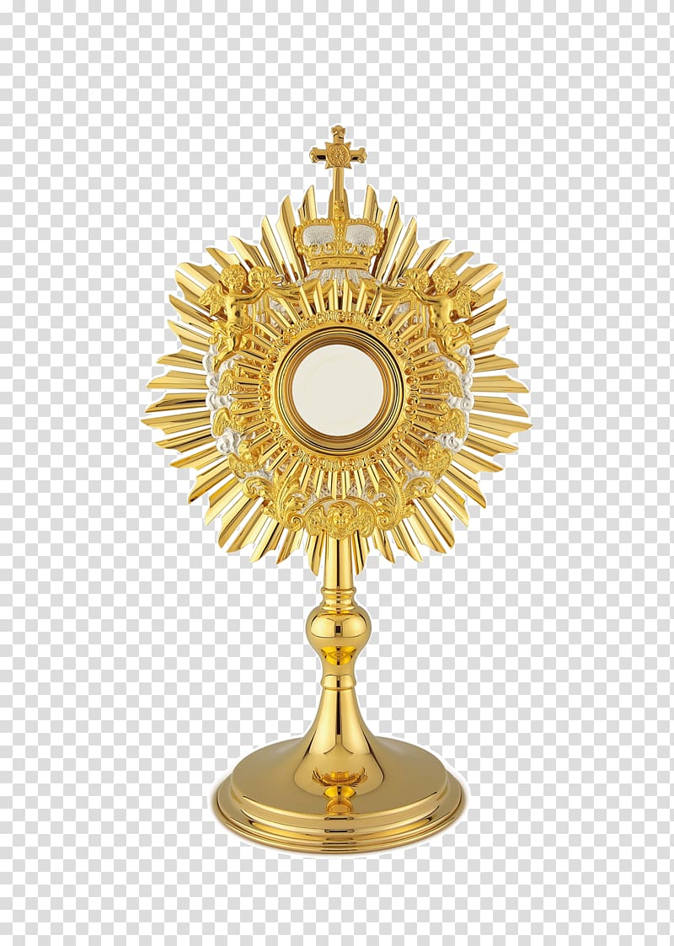
Open: The Prayer of Saint Thomas Aquinas: Grant me, O Lord my God, a mind to know you, a heart to seek you, wisdom to find you, conduct pleasing to you, faithful perseverance in waiting for you, and a hope of finally embracing you.

Does your “church life” seem different now? Does your parish have more prayer opportunities and Eucharistic Adoration times than before? Or does it just seem so since the isolation of the pandemic of 2020-2022? Personally, I think parishes are doing their best to fill the pews again with the Eucharistic Revival at the forefront. Studies show that many Catholics don’t believe in the “Real Presence” and if that is true, why would they attend Mass regularly and participate in parish events? We all probably know people who haven’t come back to Mass – they got used to staying home and watching Mass on television – and now they may not even do that. My parish priest, Father Emmanuel, emphasizes that it is his job to see we get to Heaven. That was so refreshing to hear! Two young women fairly new to our Tri-Parishes offered study sessions during Advent and Lent. The 3rd opportunity will be once a week for 5 weeks at Sacred Heart, Mondovi. (The other 2 were at St. Mary’s, Durand and Holy Rosary, Lima.) Mondovi’s will be a study on the Bible and the Mass. Several new PCCW presidents and trying to revitalize their Councils by offering more events to increase spirituality and involvement by younger women. It’s not only the younger ladies we need to reach, but all the women in our parishes. We need to surround them with spiritual opportunities as well as the usual volunteer and fun events parishes are known for.

Close: NCCW prayer “Jesus, my Jesus….”

