Lacrosse Diocesan Council of Catholic Women Meeting and Share shop October 14, 2023
The Service Commission Chair, Lorraine Reidl called the
meeting to order at 9:30 a.m.
Vice president Candace McGrath took roll and a quorum was declared.
Under new business a motion was made by Julie Brindle to pay an additional $800 towards the bench at the rosary walk at the shrine of Our Lady of Guadalupe. Kathy Herfel seconded. The bench is to honor the many years Father Wolf has served the LDCCW and the La Crosse Diocese. Motion passes unanimously.
Motion made second and approved to have Abby Johnson, the star of the Unplanned movie, speak at the April Convention on April. Natalie Goeden made the motion, JoAnne Brens seconded it.
Treasurers report by Debbie Wolfe: $49,000 was collected this spring in the Council Sunday collection.
With no other business to conduct the business meeting was concluded at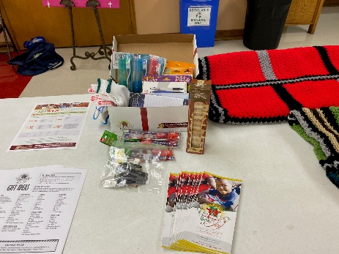 10:15 a.m.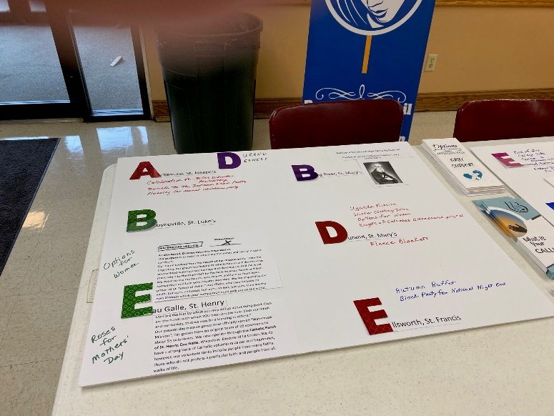
The following pictures are from each Deanery’s projects presented at the Share Shop.

Each Deanery presented their yearly projects. 