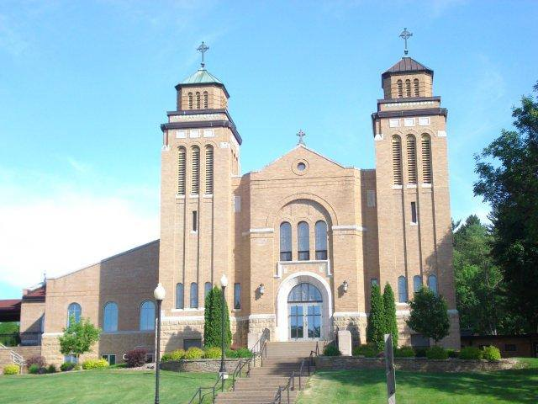
St. Mary’s Assumption Church, Durand, WI

Durand Deanery report - October 2018

St. Joseph’s PCCW, Arkansaw
Carol Konsela, president

St. Mary’s Altar & Rosary Society, Big River
Angie Dosdall, president
They hosted the Fall Durand Deanery Assembly. The speaker was Sr. Michaela Hedican, formerly of St. Bede’s in Eau Claire, now of St. Benedict’s in St. Joseph, MN. Her presentation was “Heartened by Hope” which we all need right now.

St. Luke’s Altar Society, Boyceville
Betty Garside, president

St. Mary’s PCCW, Durand
Tiffany Garner, president
A Mass mainly for Durand Deanery school children was held at St. Mary’s as part of the Diocesan Sesquicentennial celebration. Bishop Callahan was the celebrant. A Saturday-only Fall Festival was held this year. An Italian meal was served and entertainment was by Robbie Vee, son of Bobby Vee, the singer from the 1960s.

St Henry’s PCCW, Eau Galle
Lynette Wagenbach, president
There is not much to report as we do not have meetings in June, July or August and we had no special activities or events at the parish other than hosting for funeral lunches.

St. Francis Altar Society, Ellsworth
Barb Leier, president
Our pastor, the Very Rev. Eric Awortwe-Dadson was appointed Dean of the Durand Deanery following Father James Kurzinski’s reassignment to Eau Claire. Father Eric addressed the ladies at the Fall Deanery meeting in Big River.

Sacred Heart PCCW, Elmwood
Mary Ann Jensen, president
Elmwood Altar and Rosary Society has been busy during the last 6 months; in April we had a party after mass celebrating Father’s Ordination as a Priest, in May we honored Del and Jane Kannel as our May crowning family. We also honored our high school graduates with a get-together after Mass. We played Bingo at our nursing home and served coffee & rolls after Mass last Sunday of the month. Some of our ladies took the time to clean & inventory closets and shelves in server’s room and storage room. Our fund raisers paid for the outside landscaping in front of our church. June was our annual Father’s Day Pie Sale, incorporated with a farewell gathering for Father Prince. (Submitted by past president Sharon Weber)

Holy Rosary PCCW, Lima
Sara Mack, president
Another successful Fall Festival was held in August. We will be providing refreshments after Confirmation at St. Mary’s, Durand, on October 21. (Durand, Lima and Mondovi PCCWs take turns furnishing the food and serving for Confirmation.)

St. Joseph’s PCCW, Menomonie
Carol Stratton, president

Sacred Heart PCCW, Mondovi
Kathy Herfel, president
Our home visitation project has begun. Ladies are paired with a person who is housebound. One of our members has created a Facebook page for the Tri-Parishes (Durand, Lima and Mondovi). She is now working on one for the Durand Deanery. Our Fall Festival took place on September 16. The number of people attending was down – the weather was hot and the Packers were playing. The president attended the LTD workshop in La Crosse in August.

St. John’s PCCW, Plum City
Bernadine Bechel, president

St. Joseph’s, Prescott (no active CCW)
Carrie Haas, parish secretary

Sacred Heart PCCW, Spring Valley
Liz Erickson, president

